**Authentication & Profile Management**

**As a Visitor:**

* I want to register for an account so that I can join the community.
* I want to log in to my account so that I can access my personalized features.
* I want to reset my password if I forget it so that I can regain access to my account.

**As a Registered User:**

* I want to edit my profile information so that I can keep my details up to date.
* I want to upload a profile picture so that other members can recognize me.
* I want to view my activity history so that I can track my community engagement.
* I want to log out of my account so that I can secure my information.

**Events Management**

**As an Event Organizer:**

* I want to create new events so that I can gather community members.
* I want to set event capacity so that I can manage attendance effectively.
* I want to edit event details so that I can update information as needed.
* I want to cancel events so that I can notify participants of changes.
* I want to view the list of attendees so that I can plan accordingly.

**As a Community Member:**

* I want to browse upcoming events so that I can find interesting activities.
* I want to register for events so that I can participate.
* I want to cancel my registration so that I can free up space for others.
* I want to receive reminders about events I'm registered for.
* I want to view my past and upcoming events.

**TimeBank System**

**As a TimeBank Participant:**

* I want to create offers for my skills so that I can help others.
* I want to browse available skills so that I can find help I need.
* I want to request time exchanges so that I can collaborate with others.
* I want to track my time balance so that I can manage my exchanges.
* I want to rate and review exchanges so that I can build trust.

**As a TimeBank Administrator:**

* I want to moderate TimeBank listings so that I can ensure quality.
* I want to review exchange disputes so that I can maintain fairness.
* I want to generate reports on TimeBank activity.

**Digital Content**

**As a Content Creator:**

* I want to upload digital resources so that I can share knowledge.
* I want to categorize my content so that it's easily discoverable.
* I want to edit or remove my content so that I can maintain accuracy.
* I want to track views and engagement so that I can measure impact.

**As a Community Member:**

* I want to browse digital content by category.
* I want to download resources for offline use.
* I want to comment on content to engage in discussions.
* I want to bookmark content for later reference.

**Community Interaction**

**As a Community Member:**

* I want to connect with other members so that I can build relationships.
* I want to participate in discussions so that I can share ideas.
* I want to report inappropriate content so that I can help maintain community standards.
* I want to receive notifications about relevant activities.

**Administrative Features**

**As an Administrator:**

* I want to manage user accounts so that I can maintain community safety.
* I want to moderate content so that I can ensure quality.
* I want to manage categories and tags so that I can organize content effectively.
* I want to view analytics and reports so that I can track platform usage.
* I want to send announcements to users so that I can communicate important information.

**Search and Discovery**

**As a User:**

* I want to search for content across the platform.
* I want to filter search results by various criteria.
* I want to see recommended content based on my interests.
* I want to discover new community members with similar interests.

**Project Phases**

**Phase 1: Core Authentication & Basic Profile (Weeks 1-2)**

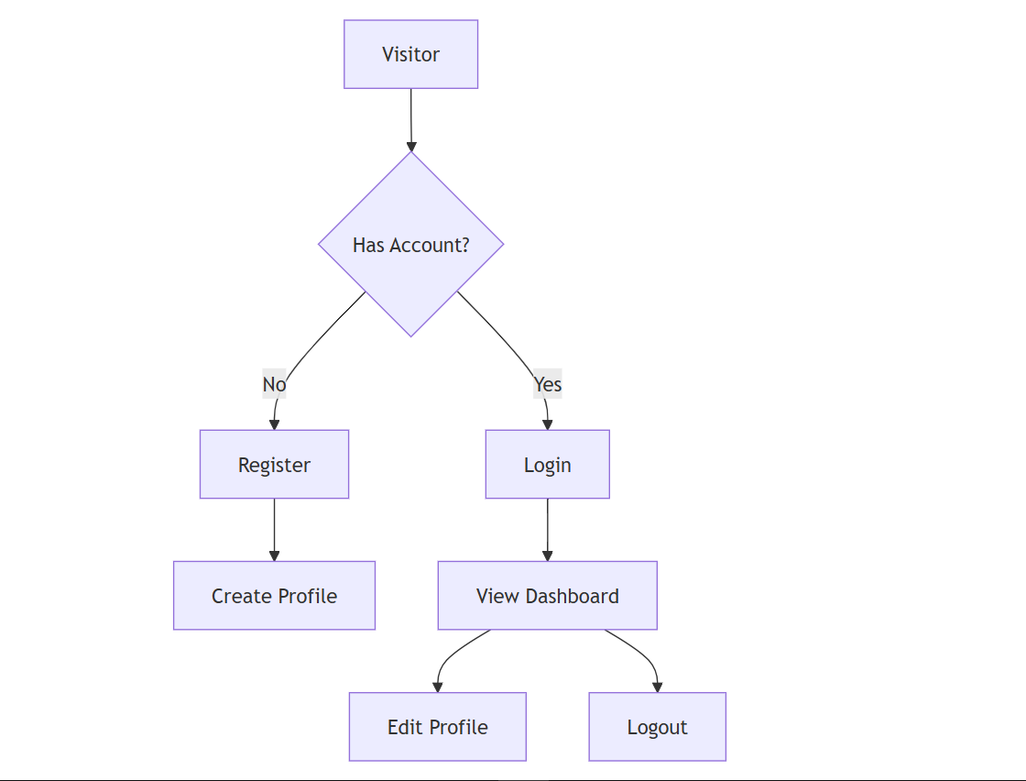

**User Stories with Acceptance Criteria**

**1. User Registration**

**Priority:** HIGH

**Acceptance Criteria:**

* Form includes: username, email, password, confirm password.
* Password must meet security requirements (8+ chars, special chars).
* Email verification required.
* Username uniqueness check.
* GDPR compliance checkbox.

**Technical Specs:**

* Django Auth System.
* JWT for authentication.
* Password hashing with bcrypt.
* Email service integration.

**Phase 2: TimeBank System (Weeks 3-4)**

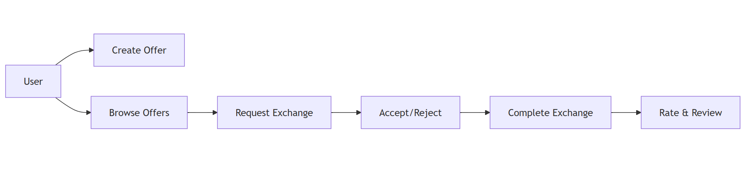**Phase 3: Events System (Weeks 5-6)**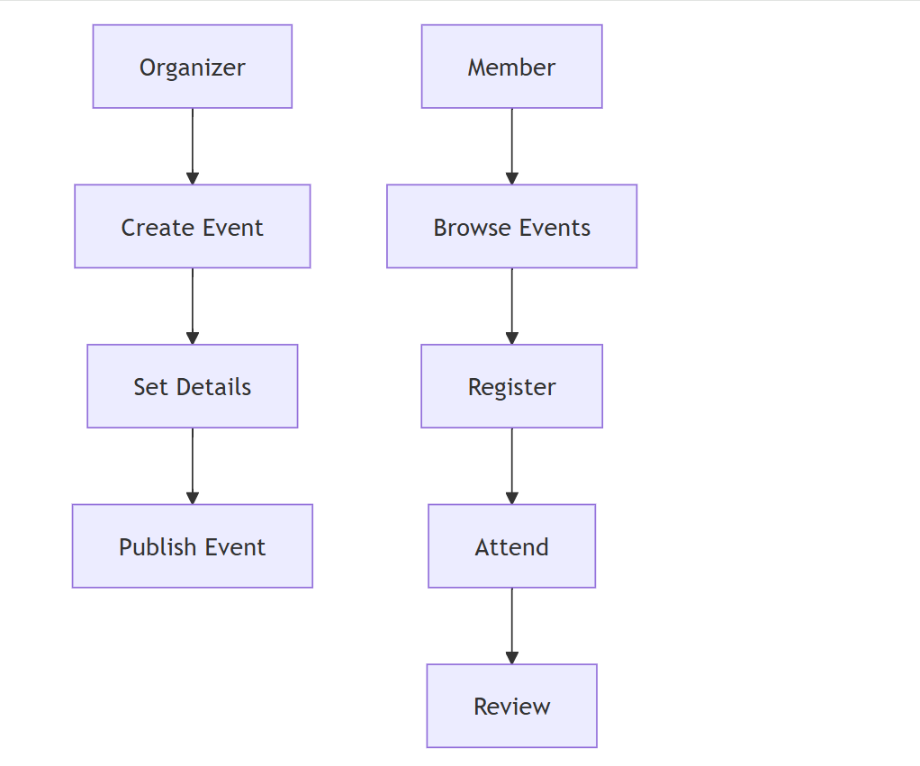

**Phase 4: Digital Content Platform (Weeks 7-8)**

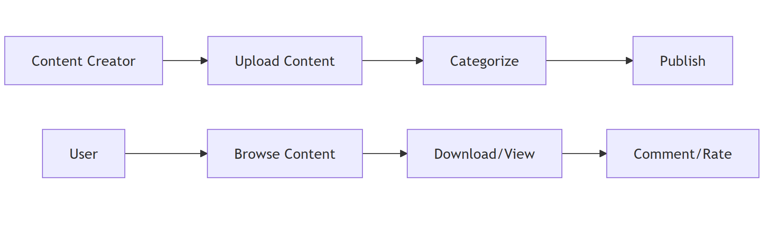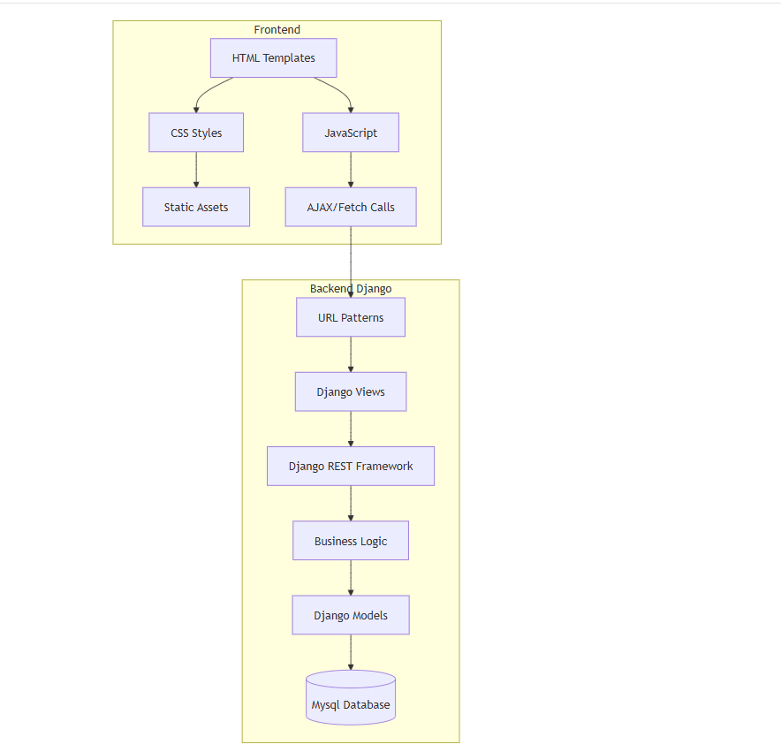

**Feature Scenarios**

**Feature: User Registration**

**Scenario: Successful Registration**

* **Given** I am on the registration page.
* **When** I enter valid details.
* **And** I submit the form.
* **Then** I should receive a verification email.
* **And** I should be redirected to profile completion.

**Feature: TimeBank Exchange**

**Scenario: Create Skill Offer**

* **Given** I am logged in.
* **When** I create a new skill offer.
* **Then** it should appear in the marketplace.
* **And** other users should be able to request an exchange.

**Security & Performance**

**1. Authentication:**

* JWT with refresh tokens.
* Password hashing using bcrypt.
* Rate limiting on auth endpoints.
* Session management.

**2. Data Protection:**

* Field-level encryption for sensitive data.
* HTTPS enforcement.
* XSS protection.
* CSRF protection.

**Key Metrics to Track**

**1. User Engagement:**

* Daily Active Users.
* Session duration.
* Feature usage.

**2. TimeBank Metrics:**

* Exchange completion rate.
* Average response time.
* User satisfaction scores.

**3. Technical Metrics:**

* API response times.
* Error rates.
* Resource utilization.

Figma Landing Page Design:

